Project Summary
Big Mountain Resort is part of the same market segment as 329 other resorts from 35 states. Exploratory data analysis results are showing that most prices appear to be in a range from $25 to $100 with California, Colorado and Utah having relatively expensive ticket prices and some states, notably North Carolina and Virginia have weekend prices much higher than weekday prices. Nevada and Utah show the most range in prices whereas Montana and South Dakota show small variability as well as matching weekend and weekday ticket prices.

Figure 1.
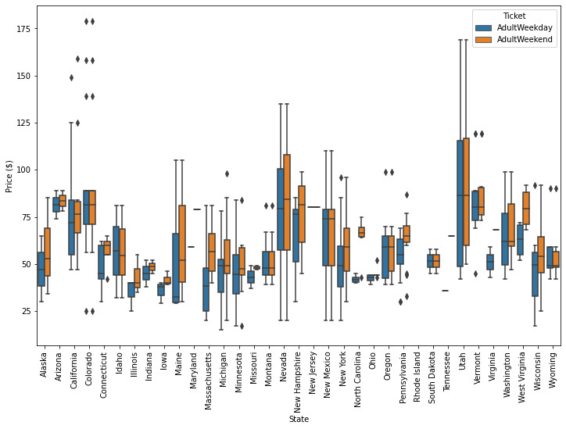

In order to better understand and identify the relationships of the data set features, a number of techniques were used to reduce the dimensionality of the data and visualize patterns:

- principal component analysis: The first two components seem to account for over 75% of the variance, and the first four for over 95%.
- heatmap as a first step at identifying patterns
- correlation analysis using scatter plots to dive into how ticket price varies with other numeric features. Based on the correlation analysis, the following five features show strong correlation:
  - fastQuads
  - Runs
  - total_chairs
  - Snow Making_ac
  - vertical_drop
Figure 2
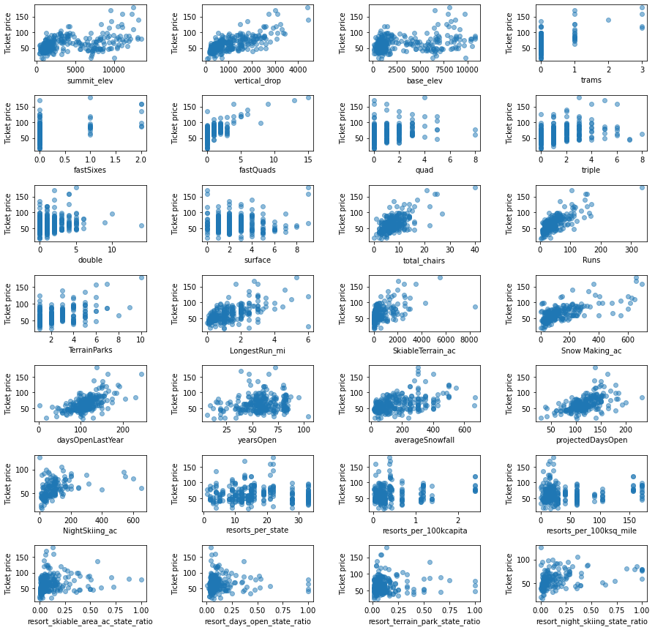

A linear regression and random forest regression model was used for the price prediction. The linear model was used initially as a baseline model and to assess the performance and variability compared to the random forest model. The random forest model has a lower cross-validation mean absolute error by almost $1. It also exhibits less variability. Furthermore, the dominant features mentioned above are in common between the two models as well as the correlation analysis.

Figure 3
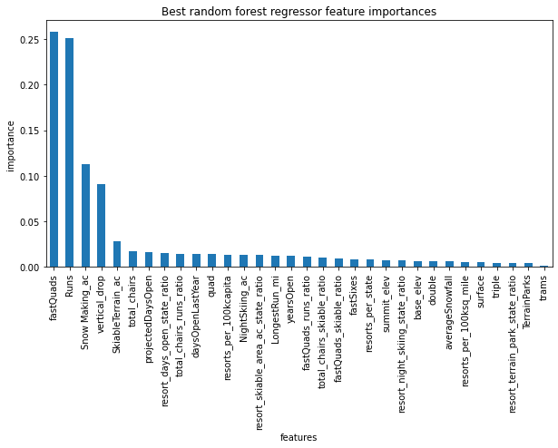

As part of modeling process, once all data is used to predict Big Mountain's ticket price, the predicted price is $95.87 almost $15 higher than the current weekend price of $81. The reason for the higher predicted price is because all resorts were treated equally since they belong in the same market segment with out any weighting or segmentation.

Finally, the following scenarios were used to analyze which one could support a higher ticket price and what level of revenue would be produced:
- Permanently closing down up to 10 of the least used runs. This doesn't impact any other resort statistics.
- Increase the vertical drop by adding a run to a point 150 feet lower down but requiring the installation of an additional chair lift to bring skiers back up, without additional snow making coverage
- Same as number 2, but adding 2 acres of snow making cover
- Increase the longest run by 0.2 mile to boast 3.5 miles length, requiring an additional snow making coverage of 4 acres

Analyzing scenario 1, the model says closing one run makes no difference. Closing 2 and 3 successively reduces support for ticket price and so revenue. If Big Mountain closes down 3 runs, it seems they may as well close down 4 or 5 as there's no further loss in ticket price. Increasing the closures down to 6 or more leads to a large drop.
Looking into scenario 2, the model is predicting that the ticket price can support an increase of $1.99 and revenue will increase by $3,474,638. Unfortunately, scenario 3 does not support any price or revenue increase compared to scenario 2 and scenario 4 does not support any increase regarding price or revenue at all.

